**CHRISTIAN MEDICAL COLLEGE & HOSPITAL, VELLORE.**

**INTERNSHIP WORK**

Submitted for the partial fulfillment for the award of the

**BACHELOR DEGREE**

**IN**

**HOSPITAL ADMINISTRATION**

**Submitted by**

|  |  |
| --- | --- |
|  | **ARTHI.V**  **(30517U43004)** |

**Check for alignment**

**Have made changes in capital letters**

**Introduction**

In 1900, the Christian Medical College was started by Ida S. Scudder, an American missionary, as a one-bed clinic to serve women. At present **CMC** has 2300 beds on four sites, with all specialties. Patients from all over India and the world come for treatment.

IntroductionBOLD THIS

The Christian Medical College Association is a non government, private, inter-denominational Christian organization. The object of the association is the establishment, maintenance and development of a Christian Medical College in India where women and men shall receive an education of the highest grade in the art and science of Medicine and Nursing or in one of the Allied Health professions, AND to equip them in the spirit of Christ. The CMC community today is made up of an interesting and diverse group of people- students and faculty come from all over India. Visitors come from Australia, Britain, Canada, Denmark, Ethiopia, France, Germany, Kenya, the Middle East, New Zealand, USA and many other countries. The interchange between varied people and cultures provides a rewarding and stimulating experience.

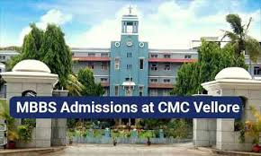

**CHANHE THIS PIC USE ONE WITHOUT THE LINE MBBS ADMISSION**

**Acknowledgment**

The completion of this study would have been impossible without the material and moral support from various people. It is MY obligation therefore to extend MY gratitude to them. First of all I thank the almighty god for giving ME good health and guiding ME through the entire course.

I would like to thank Dr. (sr.) Regina Mary.R, Principal, Auxilium college (Autonomous), Vellore for giving us this opportunity and permitting ME to do this internship work as a part of our curriculum.

I take immense pleasure in thanking Dr. Beulah Suresh, Head, Department of Business administration, Ms. Preethi prabhakaran, Head in charge, Department of Business administration (Hospital Administration),Ms. Subha chandra, Assistant Professor and Ms. Sripriya.SA, Assistant Professor for their guidance and support for the successful completion of our internship.

Last but not least we would like to thank our friends and our parents for their support and blessings.

**Central sterile supply department (CSSD)**

**History of the department**

The central sterile supply department was organised in the year 1972. As far back as 1946 a cssd had been envisaged by the director but it was just until about 1969 that such aN area was planned and incorporated into a structure of CSSD. The external structure was completed by 1971. It took one year for the department to set up and function. Miss Thompson was the pionEER and she was the in charge and served from the beginning. In 1973 Mr. William carry took over the responsibility from 1974. Mrs. Meeramani took over as in charge and serviced up to 1994. Then Mrs. Ruth Edward took over as in charge and served from 1994 top 2010. Then Mrs. Shanthakumari took over as in charge from 2010 to 2015. From 2015 Mrs. Florence ponnie took over as in charge till date.

**No of staffs employed:**

Total NUMBER of staff employed -72 NURSES- 6 incharge-1 number of charge nurse-1 junior engineer-1 staff ANM\MPHW-14 clerck-5 autoclave-4 hospital attenders-35 REWRITE THIS LINE PROPERLY

Definition :

CSSD IS referred as **Central Sterile** Services **Department**, an integral part of **CMC** Vellore Chittoor Campus that performs different methods of **Sterilization** on medical devices, equipment and consumables which are safe for patient use and care. CSSD plays an important role in delivering an infection free zone.

**Functions of the department:**

Cssd department is an integral part of cmc, that performs different methodS of sterilization and medical devices equipment and consumables which are safe for patient use and care. Cssd plays an important role in delivering an infection free zone AND the serviceS include pre-vacuum steam stereilization, eCo gas sterilization and hydrogen peroxide plasma sterilization. They provide around 1950 sterile packs daily to serve the outpatients.

**Organgogram:**

1

Nursing superintendent

General superintendent

Autoclave operators, artisan electrician (Technical),

Hospital attenders and hospital house keeping attenders

MPHW-muti purpose health worker and nursing auxiliary/HA

Junior engineer

clerk

Staff nurse

Charge nurse

Charge nurse

(in charge)

END A SENTENCE WITH FULL STOP.

**Work done in cssd:**

* DURING THE first week OF INTERNSHIP I WAS assigned in cssd that is central sterile supply department
* First day I was assigned in auto clave room WHERE I helped them TO SEPARATE the packages and also helped them by doing some paper works over there.
* The second and third day I was assigned in packing area. We did works like sticking the label ON packed items and separated the washed items according to their section and arranged the brauze(WHAT WORD IS THIS) in proper way and also wrote some load number On stickers.
* The last day I was assigned in gas sterilization room. There I helped them in sticking the label and arranged the packing cover, sealed the covers for sterilization.

**Learning:**

* Different types of machines in autoclave room for sterilization

1. Pre-vaccum sterilizer

2. Gravity sterilizer

3. Hot air oven

* Different types of packages like dressing pack, pernital care ,suction tray, blood culture tray, bivalve drum.
* Gas sterilization: it is sealing the items and sterilized for 16 hours under 50 DEGREE CELCIUS and they use ethylene oxide for sterilizing the items.

**Quality management cell**

**History of the department:**

In Christian medical college quality management cell was established in the year of 2007. It was started by Dr.Thomas and Dr.Lallu Joseph. In 2011 Mr. Rabindranath WAS appointed as audit facility officer. Before that two staffs worked in that position. Later they selected department quality manager in every clinical and non-clinical department. In every department they selected one staff as department quality manager to access their own department. NABH- National accreditation board for hospital and healthcare was applied for full accreditation level.

**No. of Staffs employed:**

CHECK WHETHER THIS IS CORRECT THERE ARE TOTALLY 10 staffs INCLUDING Dr. Bibila chacko (Hod), Dr. Lallu Joseph (Manager), Mr. Rabindranath (audit facilitation officer), Dr. Shalon (patient safety officer) gm officer, Ms. Anitha ( nurse manager), Mr. Ruben (safety officer ), Mr. Joil (administrative assistant) AND Ms. Indumathi (secretary)

**Definition:REMOVE THIS HEADING**

**I DONNT UNDERSTAND THE BELOW PARAGRAPH**

**Quality Management Cell** HAS WON BMJ South Asian award 2017 for Quality AND IS capable of producing high-**definition** images within a minute; I DON’T UNDERSTAND a separate Cardiac Care. A **CMC** Strategy Forum from 2010 details three workshops covering quality. How much can be handled by a company's **quality management** (e.g., increasing blood- **cell** levels are easier to measure than tumor size or overall survival). Again some commenter’s consider that **definition** to be too vague.

**Functions of the department:**

The quality management team of cmc Vellore bagged the coveted quality improvement team award of the BMJ Award south Asia, which aims to honor individuals and team across south Asian countries working towards improvement in the quality of healthcare services. More than 200 nominations from eight countries were invited AND cmc was the only INDIan inSTItution AMONG THE two finalists. The QMC in the quality improvement team category. Dr. Lallu Joseph quality manager along with Santhosh varugnese, deputy director (quality and Hr) and vikram Mathews associates director received the award from ashwini Kumar , minister of state, union minister of health. GIVE THIS PARAGRAPH IN INTRODUCTION OF THE DEPARTMENT.NOT UNDER FUNCTIONS

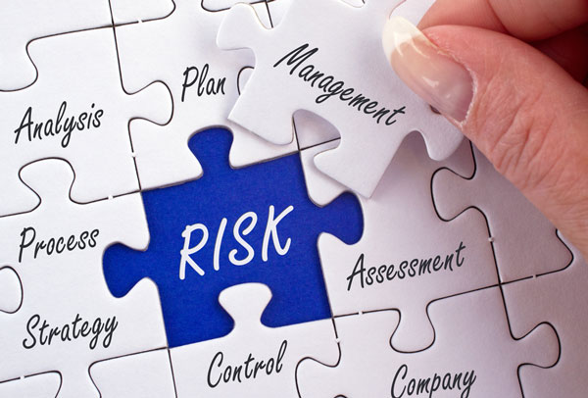

**Y THIS PICTURE**

**Quality management cell**

History of the department: Y REPETITION

In Christian medical college q2uality management cell was established in the year of 2007. It was started by Dr.Thomas and Dr.Lallu Joseph. In 2011 Mr. Rabindranath appointed as audit facility officer. Before that two staffs worked in that position later they selected department quality manager in every clinical and non-clinical department. In every department they selected one staff as department quality manager to access their own department NABH national accreditation board for hospital and healthcare was applied for full accreditation level

No. Of. Staffs employed:

10 staffs and Dr. Bibila chacko (Hod) Dr. Lallu Joseph (Manager) Mr. Rabindranath (audit facilitation o0fficer) Dr. Shalon (patient safety officer) gm officer Ms. Anitha ( nurse manager) Mr. Ruben (safety officer ) Mr. Joil (administrative assistant) Ms. Indumathi (secretary)

**Definition:**

**Quality Management Cell** wins BMJ South Asian award 2017 for Quality. Capable of producing high-**definition** images within a minute; a separate Cardiac Care. A **CMC** Strategy Forum from 2010 details three workshops covering quality. How much can be handled by a company's **quality management** (e.g., increasing blood- **cell** levels are easier to measure than tumor size or overall survival). Again some commenter’s consider that **definition** to be too vague.

**Functions of the department:**

The quality management team of cmc Vellore bagged the coveted quality improvement team award of the BMJ Award south Asia, which aims to honor individuals and team across south Asian countries working towards improvement in the quality of healthcare services more than 200 nominations from eight countries were invited cmc was the only intuitions that had two finalists. The qmc in the quality improvement team category. Dr. Lallu Joseph quality manager along with Santhosh varugnese, deputy director (quality and Hr) and vikram Mathews associates director received the award from ashwini Kumar minister of state, union minister of health



Orangogram:

Deputy director

attender

2 feedback staffs

secretary

Management inerms

assistant

administration

Safety manager

Nurse manager

Patient facility officer

Audit facility officer

Quality manager

**Work done:**

* FROM 10.2.2020 to 4.2.2020 I was assigned IN QMC that is quality management cell and there we UNDERSTOOD the quality management department manual history, objectives, profile mission and vision of the department.
* Mr. Rabindranth (audit facility officer) explained about the quality and needs of the quality and he TAUGHT US very briefly about NABH (National accreditation board of hospital) and also he gave information about legal and illegal(WHAT) forms of every department
* And I went to collect the feedback from different types of patients in radio therapy department and entered it in audit forms
* I went to isscc building and inspected the Q6 south ward in WHICH I found many unclean things. I did some data entry work after which I went to Award(WHAT IS THIS) to collect feedback from inpatients
* I went to isscc (pediatric) to check the history sheet, patient discharge etc..
* We attendED fire safety class conducted by quality management cell and also attended the fire mock drill conducted by quality management.

**Learning: REPLACE THE WORD LEARNED BY LEARNT**

* I learned about three different types of accreditation such as Entry, Progressive and Full accreditation. And also learnt about NABH accreditation. It has 10 chapters 106 standards and 638 objective elements.
* I learnt about different types of departments like hematology, dermatology**.**
* I learnt the three types Of fire extinguishing methods- they are condensed, controllable, and uncontrollable. There are three elements of fire triangle such as heat, fuel, and air.

**Medical records department**

**History of the department:**

Cmc did not have any system of medical records unit UNTIL 1925. THERE was a system of records keeping WHICH WAS introduced for inpatients. In 1930, some personnel were trained as record clerks. Dr. A.L Kinnean who is the medical superintendent standardized medical forms. Dr. Johncarmen WAS APPOINTED as advisor to the department. She effected many improvements. She felt the need of having a trained medical records librarian. In 1995 the Rockefeller foundation made a grant of Rs 33,000 to the department and agreed to award a fellowship for a person to be trained in USA.

**No. of Staff employed:**

The total number of STAFFS employed is 180. It comprises OF one Hod, two tutors and other staffs are MROs, Technicians, Housekeeping STAFFS, attenders, office administrators and hospital attenders.

**Definition:**

Medical Records (MRs) is a set of documents that renders the clinical, para-clinical care, and financial information(WHAT IS THIS) about the patient. The Medical Records Department (MRD) is responsible for collecting, and protecting patient information, and for disseminating it to the right people or TO THE organization, in order to promote the quality of patient care



Functions of the department: CHANGE mrd TO MRD

MRD is considered to be the face of the hospital in the view of the patient and it is the backbone of the hospital. The whole documents of the hospital ARE recorded in the mrd. This serves AS a proof of all outpatient and inpatient treatment and consultation. mrd is also meant for the study and research purpose AS IT is used by doctors inTENRs and students

**Orangogram**

Healthcare institutions

Medical superintend

Hospital attenders/ house keeping staffs

internal

students

Service obligation staff

Mros and Mrt

incharge

tutors

Head of the department

**Work done:**

* I wentto take CENSUS in the various department and also I did some chart arrangements according to assembling order. Wrote the folder names of a file for the reference and research
* I went to orthopreties(CHECK WHAT IS THIS) opds and MRO counter both general and private. There I observed the process done.
* I was assigned in statistics area WHere I observed the statistics process and how they are calculating the statistics. In MRD they are maintaining differenT statistics for outpatient and different for inpatient.
* In statistics they are following the rules and protocols of the government

**Learning:**

* I learnt the process of medical records department. In that I learned about different process of admission data, correction and enquiry area.
* Learnt how to take CENSUS in various department and formula to calculate that is beginning of PATIENTS of the day +admission of patient+patients transferfrom-eqpiry date-discharge-patient transfer to ward.
* I learnt how to scan and index the prescription sheet and also learnt how to responD to patients
* Learnt the process and protocols of statistics and also learnt how to separate statistics based ON inpatient and outpatient.

**Materials department**

**History of the department:**

The materials department is the centralized procurement unit of cmc WHICH procures, receives stocks and distributes the materials to the user department as per their need in a scientific and systematic way. The materials include large equipments to small consumables other than drugs and medicines needed for the institution. In the year 1951, the old engineering room was converted to a store go down for the storage of materials purchased by the institution. The store keeper was appointed in the year 1952.

**No. of staffS employed:**

1- hod, 1- G.M. officer, 4 –supervisors, 6-clerk typist, 1- secretary and 2- attendErs totally 15 members employed in purchase department.

Definition: TYPE THE DEFINITION PROPERLY. IT IS NOT CLEAR. USE ALL FULLSTOPS AND COMMAS WHEREVER REQUIRED

The **CMC** Project **Manager** has an overall understanding of **CMC** function, WHICH will help **define** deliverables and manage assigned **CMC** related activities, with Supply **Manager** to support planning and packaging of clinical WHAT( INCOMPLETE IT IS). To appropriately manufacture a pharmaceutical or biologic specific manufacturing processes, product characteristics, and product testing must be **defined** in order to ensure that the product is safe, effective and consistent between batches

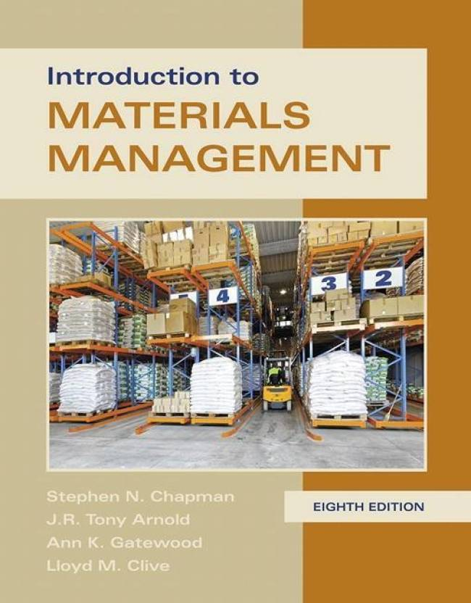

**Functions of the department:**

It procures all the items to Christian medical college except the medicines and drugs. It has four different types of ordering which includes regular order, confirmatory orders, standing orders and import orders. The foreign orders(or) import orders ARE placed with overseas vendors in foreign currency, regular order is the process of giving the delivery period, confirmatory order is based on direct purchase by user department anD standing order is based on the time agreement with vendor

**Orangogram:**

General superintendent

Head materials department(senior manager)

Associate general superintendent material

Stories unit (supervised by the incharge)

Purchase unit

CRS unit (supervised by incharge)

**Work done:**

* I was posted in follow-up area wHere I WAS REQUIRED to make a call to suppliers and should verify about the ordered materials.
* I observed the process of follow-up and then I did a work in the follow up area
* The work of follow up is to call to suppliers and should ask WHEN THE materials WILL BE supplIED and if they HAVE not supplied materials should ENQUIRE ABOUT reason for the delay of supply.
* And I did some import scanning in the scanning area
* The FREQUENTLY orderED materials are general stores, linen stores, engineering electricalS, operation theatre, stationery stores, and nursing service.

**Learning:**

* I learned the process and protocols of the follow-up in the materials management and also I learnt how to MAKE FOLLOW UP CALLS TO the suppliers
* I also learnt about the material coding
* I learnt the scanning process and procedures. Scanning is done to refer for the future use and also to reduce mistWHAT IS THIS of the paper works.

**Reception**

**History of the department:**

Reception plays a vital role in an organization. The reception training program was started in 2008**.** It is the front or window to the organization.People rate the organization by its reception. IN reception it is important to have a good uniforms relations. The proposal was given to the people to attend the training program AND it’s been 12years the reception department is started. There were volunteers gUIDING the patients before the reception programme was started. The volunteers didn’t have PROPER training and the REQUIRED qualities.

**No. of staffS employed:**

There are totally 25 staffs employed in reception. 15-16 staffs are receptionist AND THE other 10 are trainers. 1-hod and also 110 CTT staffs ARE working along with them.

**Definition:**

Hospital receptionists work in hospitals and help patients, answer phones, assist patients, handle mail, file records and make sure medical offices are runninG smoothly. Receptionists are also responsible for giving patients information on what is happening in the clinic and checking them in for appointments- Education.

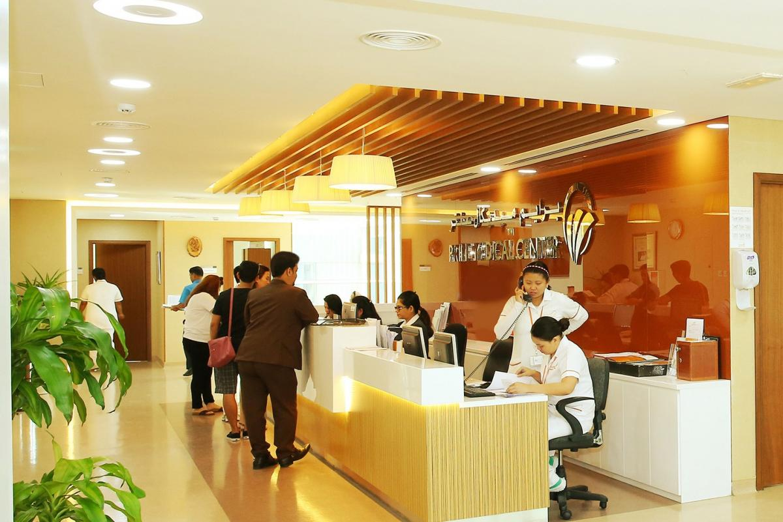

**Functions of the department:**

Reception is the window of the hospital. First and foremost the patients or ANYONE coming to the hospital comes to reception to know all the information about the hospital. Reception gives the first and everlasting impression about the hospital. The most important quality of the receptionist is they must be politE and courteous in handling the patients. Receptionists are always glad to welcome people or patients with a smiling face and to resolve their doubts and also satisfy the patient’s needs.

**Orangogram:**

Medical superintendent (patient care

Deputy medical superintendent

Front office co-ordinator

Receptionist

**Work done:**

* I was posted in alpha clinic- uroflow reception. The number of that reception is 624. There I observed the process of that reception
* I was in triage r(401) reception. There also I observed the process and producers of that reception
* In G-12 reception which is located in OPD building I observed the work done by the receptionists and I guided some of the patients who asked doubtS about their appointments.
* In PMR( physical medicine rehabilitation ) which is located NEXT TO casualty I observed the process of the receptionist and guided some of the patients

**Learning:**

* I learnt the uroflow process test and types: post void residue (PVR) uroscan, cytoscopy urodyamics and video CMG cystometrogram.
* In triage learnt about different types of counters such as

1. counter 2,3,4 - OPAD counter

2. counter 5,10 – it is a muLti function counter

3. counter11,12 – repeat registration

4. counter 13 – fastrack counter

5. counter14 – staff relative counter

6. counter 15 – pediatric emergency

7. counter 9-32 – supervisors room

* I learnt about therapist such as physiotherapy and electrotherapy. In physio therapy many conditions are converted. Electrotherapy is done for pain relief. I DON’T UNDERSTAND THE REST OF THE SENTENCE hemophysician restibulan facial palsy electrical stimulation bio feedback

**Hospital management studies and stAff training and development**

**History of the department:**

Department of hospital management studies and staff training development came to function on November 14,2009. Their department waS created by the REQUEST OF THE institution. Dr. Samuel N.J. David who was upto then the Sr. personnel manager in the personnel department of cmc BECAME THE head OF this new department. This department was inaugurated on December 18, 2009 and it seeks to assess and address the training requirements (HRD) of the staff in cmc Using both intramural and extramural faculty under the directorate in particular the associate dIrector (HRD) and under the principal for all hospital management course.

No. of. Staff employed:

The total number of staffs in their department is 8, which compriseS of 5 – permanent staffs and 2 - management interns and 1 – course coordinator

**Functions of the department:SO MANY SPELLING MISTAKES WHICH COULD HAVE BEEN AVOIDED. TYPE PATIENTLY**

* Conducting training need analysis for various categories of staff.
* Interacting WITH the supervisors/ hods as part of training need analysis and identifING the area where training is required for their staff.
* Train staff of various categories using inteRNal and eXternal resource persons
* conduct the following training programme in liaison with administrative offices
* institutional induction training programme one day programme for doctors under principal anD M S – office in English.

**Orangogram of the department:**

director

Principal

Associate director

HRD

attendant

1 course co - ordinator

secrateries

Associate professor/office (Admin/2)

Management studies and various teching programmes

Staff training and development

Management studies

Sr. manager of HOD staff training (HR)

**Work done:THE FONT TYPE IS NOT TIMES NEW ROMAN**

* From 09.03.20 to 13.02.20 I was posted in the department of hospital management studies and staff training and development.
* There I read A book name called THE TIPPING POINT BY Malcolm gladwell. Malcolm gladwell has been a staff writer IN new Yorker since 1996. He is the author of three OTHER bookS called the power of thinking without thinking, the story of success, what the dog saw.
* After reading the book I prepared the power point presentation based on that book

**Learning:**

* The main characters in the tipping point is hush puppies, pacel revere, William dawes, roger horchow,lois weiberg, rod steiger mark alpert.
* I learnT many things in that book and also studied many new words. I gained more English knowledge.

GIVE FEW LINES FOR CONCLUSION